Title : Natural Language Explainable CKD Prediction via Fine-Tuned LLMs
Abstract :
Enhancing clinical prediction systems with explainable reasoning is critical for trustworthy deployment in healthcare. While traditional machine learning models achieve strong performance on structured clinical data, their reliance on technical post-hoc explainability limits accessibility for non-technical users. Recently, Large Language Models (LLMs) have shown promise in generating human-readable explanations; however, their application to tabular medical data remains challenging due to the inherent mismatch between structured inputs and language-based models. In this paper, we address this challenge by integrating table-to-text serialization into an end-to-end LLM-based Chronic Kidney Disease (CKD) prediction framework. Specifically, we fine-tune a medical LLM on serialized clinical tabular data using parameter-efficient techniques (LoRA/QLoRA), enabling the model to perform CKD classification while generating patient-specific natural language rationales. We conduct extensive experiments on three heterogeneous CKD datasets and benchmark the proposed approach against a Random Forest baseline. The results show that while traditional models remain superior for large-scale tabular prediction and regression tasks, LLMs provide comparable classification performance on smaller datasets and significantly improve the accessibility and usability of explanations. These findings highlight a fundamental trade-off between predictive optimality and human-centered explainability and provide practical insights for developing clinically interpretable AI systems.
1. Introduction :
Chronic Kidney Disease (CKD) is a progressive decline in kidney function that often goes undetected until its later stages, reducing filtration rate and ultimately leading to the need for dialysis or transplantation [1,2]. It is a major global health burden, affecting roughly 10% of adults worldwide and more than 800 million people overall [2], putting a heavy burden on healthcare systems due to its high prevalence and costly treatments. Early detection and identification of this disease are crucial for enhancing patient outcomes [3] and alleviating the burden on healthcare systems. Traditional diagnostic approaches, primarily the glomerular filtration rate (GFR) and urine tests for albumin, are useful for diagnosing and monitoring Chronic Kidney Disease (CKD) but remain ineffective in accurately predicting its progression or identifying the most significant factors contributing to its development [3].
Recent studies demonstrate that supervised Machine Learning (ML) and Deep Learning (DL) models trained on structured clinical data can predict CKD presence, stage, and progression with remarkable accuracy, often reaching the 99% mark [4,5,6,15]. Tree-based machine learning methods, including random forest, XGBoost, and gradient boosting, as well as neural network models, consistently demonstrate strong predictive performance across studies and emerge as top performers [1].
Despite these advances, most of these models still behave as ‘black boxes’, as they are hard to understand and provide almost no information on why a prediction is made [2]. Clinicians need not only accurate risk scores but also transparent, patient-specific explanations that facilitate decision-making and help identify potential model errors or biases [7,8]. In response, recent studies have increasingly integrated predictive modeling with explainable artificial intelligence (XAI) techniques such as Shapley Additive exPlanations (SHAP), Local Interpretable Model-agnostic Explanations (LIME), and fuzzy rule-based systems to highlight the contribution of individual features behind each prediction, thereby providing transparent outputs that can support clinical decision-making [2,7,8].
However, still several challenges still remain. According to this study [9], XAI methods provide valuable insights into feature influence; primarily offering technical attributions and plots that require specialized expertise to interpret and do not directly deliver intuitive, human-centered rationales for individual predictions. In contrast, rationalization aims to justify model outputs through natural-language explanations that explicitly articulate the reasoning behind a prediction. Such rationales are inherently human-comprehensible and accessible to non-technical users, making them particularly valuable in clinical settings where transparency and trust are essential.
In parallel, Large Language Models (LLMs) have emerged as powerful tools capable of generating human-like, natural language text responses (rationales) to diverse user queries [10], and application of these models is currently being explored on tabular data as well [11,12,13]. To directly address the need for user-friendly and justifiable explanations mentioned in these studies [1,9], we propose a novel methodology that leverages the Natural Language Generation (NLG) capabilities of Large Language Models (LLMs) to create intuitive, easy-to-understand rationales for CKD prediction while supporting the need for AI integration in kidney disease care.
Specifically, the objectives of this work are:
- To propose a novel approach that utilizes LLMs to generate case-specific natural language rationales explaining each CKD prediction;
- To benchmark large language models (LLMs) against traditional machine learning models for CKD prediction on clinical data.
The primary focus is to employ LLMs directly for classification and analyze their predictive performance and reasoning , an aspect that has not been explored in previous studies
The remainder of this paper is organized as follows. Section II reviews related work, Section III describes the proposed methodology, Section IV presents the experimental results and discussion, and Section V concludes the paper.
2. PREVIOUS WORK:
ML and DL models are densely used in healthcare for disease prediction and prognosis. Speaking of nephrology , and more specifically CKD several studies have been carried out for CKD prediction and utilizing techniques to improve model performance. Almost all of these studies have utilized supervised learning techniques electronic health records (EHRs), laboratory test results, and patient medical histories.
Recent study [14] have compared Logistic Regression , K-Nearest Neighbor (KNN) , Tree based model i.e Decision Trees and Random Forest (RF) on CKD classification . The dataset used in this study was collected from Bab Al-Rayan Clinic Center and the dataset consists of 100 patient records. KNN, Logistic Regression, and Random Forest all achieved an accuracy of 95%, while Decision Tree achieved 90% accuracy. While in scenario 2 , Feature Selection with Recursive Feature Elimination (RFE) was implemented on dataset and selected features were used for model training. KNN achieved the highest accuracy of 100%, followed by Logistic Regression at 95%, and Decision Tree and Random Forest at 90%. Another study [15] used 25 variables dataset and reduced its dimensions with Principal Component Analysis (PCA) and compared multiple algorithms and it was found out that XGBoost Classifier surpassed every other model with 99.1% accuracy. There was another study [16] that used Artificial Neural Network (ANN) and compared it with ensemble methods like XGBoost and Random Forest. The dataset for this study was obtained from the UCI Machine Learning Repository which has been used in a lot of studies. ANN topped the leaderboard with 97.5% accuracy followed by XGBoost 96.25 % and Random Forest 96 % respectively. Study [17] evaluated four models ,apart from KNN and RF , Support Vector Machines (SVM) and Naïve Bayes (NB) were also used. CKD dataset form UCI ML repository was utilized , SVM achieved highest accuracy of 99.17 % followed by KNN and RF . NB performed the worst due to its due to its that features are independent and got an accuracy of 63.33%. Another study [18] compared Ada Boost Classifier, Cat Boost, Stochastic Gradient Boosting, Gradient Boosting Classifier, Extreme Gradient Boosting, Extra Trees Classifier apart from above mentioned models and Extra Trees Classifier and XGBoost topped the leaderboard with 99.16%. These studies shows that almost every supervised learning model has been used fo CKD prediction.
Recent studies also demonstrates a growing application of Explainable AI (XAI) techniques to improve the interpretability and clinical utility of Chronic Kidney Disease (CKD) prediction models.[3] used Explainable (XAI) techniques like Shapley Additive Explanations (SHAP) and Local Explainable Explanations (LIME) specifically to demonstrate the influence of the features on the on model and for individual prediction. Another study [19] employed Partial Dependence Plots (PDP) and Accumulated Local Effects (ALE) along with SHAP and LIME.PDP provide global interpretability by illustrating how variations in one or two features, such as hemoglobin or serum creatinine, influence prediction outcomes. ALE refine these insights by correcting for feature correlations, thereby offering more reliable local explanations of biomarker contributions to CKD risk. [20] emploted Bayesian optimization driven interpretability, calibration curves, macro-averaged fairness metrics alongside SHAP. These additions make the model’s predictions more clinically trust worthy and reliable. Together, these studies demonstrate the expanding role of diverse XAI techniques in making CKD prediction models more interpretable, clinically reliable, and trustworthy.
Beyond traditional interpretability, the recent emergence of LLMs has opened new avenues for human-centered AI in healthcare. More recently, researchers have begun exploring the application of LLMs to structured clinical data. For instance, the TabLLM [11] and TabPFN [20] framework demonstrated that LLMs can provide comparable performance to traditional ML models and even beat them in zero or few-shot classification on tabular health records but overall they can’t beat ML models in tabular prediction also stated in this study [21]. However, most of these studies focus primarily on the predictive accuracy of the models. There is a significant research gap in utilizing self-explanation prompting to generate specific natural language clinical rationales for CKD. Our work addresses this by not only benchmarking predictive performance but also evaluating the model's ability to articulate the underlying clinical reasoning in natural language.
3. Methodology :
This section describes the proposed framework. It begins by explaining how the data was collected and transformed. Next, it presents benchmarking results comparing the Large Language Model (LLM) with traditional Machine Learning (ML) models. Finally, it outlines the approach used to generate natural language responses for each prediction.
To provide an overview of our methodology, we first present the overall architecture before detailing the data collection process.
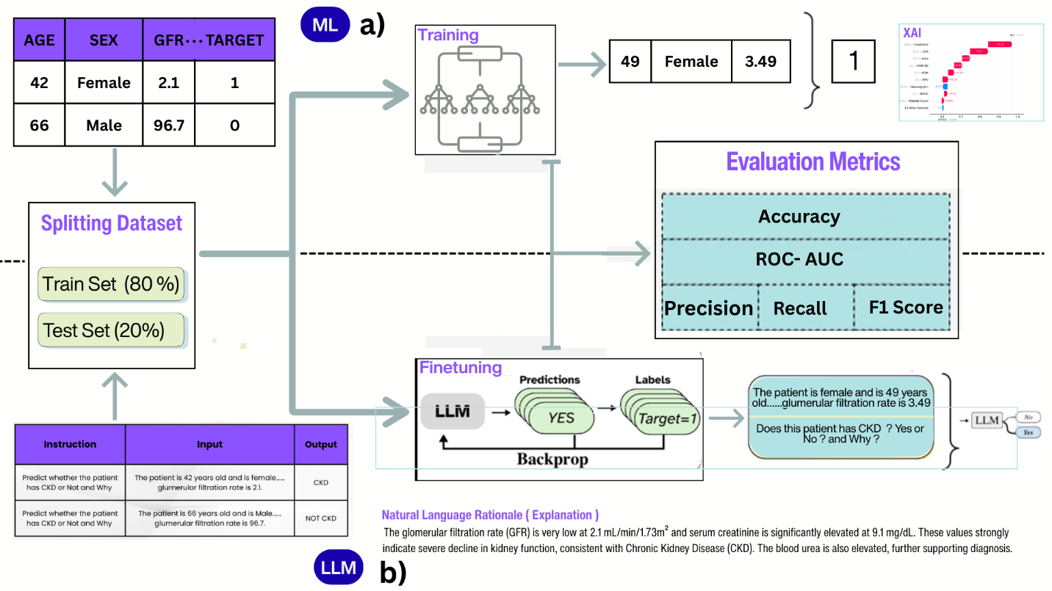
Figure 1. Overview of the proposed CKD prediction framework. Section (a) illustrates the Machine Learning (ML) pipeline using structured tabular data, while Section (b) depicts the Large Language Model (LLM) pipeline leveraging natural language inputs and rationales.
3.1. Data Collection
Three CKD-related datasets were employed in this research , comprising of individuals with and without chronic kidney disease. These datasets were sourced from clinical centers and opensource dataset repositories. By utilizing multiple datasets , we aimed to test whether the approach generalizes well on diverse datasets rather than reporting results from only one dataset. Collectively these datasets encompasses :
- demographic variables such as age, gender, and ethnicity
- laboratory measurements including serum creatinine and estimated glomerular filtration rate (eGFR)
- clinical observations such as blood pressure, diabetes status, and reported symptoms.
3.1.1. Data Sources
- Details about the datasets is provided below :
  - Pakistan Kidney Center (PKC) Dataset (pkc): This is a region specific dataset collected form Pakistan Kidney Center , Abbotabad. It is not publicly available.
  - UCI Chronic Kidney Disease Dataset (uci): This dataset was downloaded from University of California Irvine Machine Learning Repository and is publicly available.
  - Spanish CKD Dataset (spn): This dataset was downloaded form Kaggle . It is named as Spanish because it was in Spanish Language and was later translated to English. It is also publicly available under the title “Dataset_insuficiencia_renal_crnica” on Kaggle.
Further detail about the datasets is provided in provided in Table 1 below.
Table I. Dataset Characteristics
Dataset Name | Total Features | Categorical | Numerical | Shape (rows,cols)
PKC CKD Dataset | 22 | 2 | 20 | 398 , 22
UCI CKD Dataset | 25 | 11 | 14 | 400 , 25
Spanish CKD Dataset | 20 | 6 | 14 | 15050 ,20

These datasets contained variety of features but there were some features that were common in all three datasets which are shown in Table ii.
Table II. Common Clinical Features Across Datasets
Common Feature | Column Names Used in Datasets | Data Type
Age | (Age, age) | Numerical
Blood Urea | (Blood Urea, bu, Urea) | Numerical
Serum Creatinine | (Serum Creatinine, sc, Creatinine) | Numerical
Hemoglobin | (Hemoglobin, hemo, Haemoglobin) | Numerical
PCV / Hematocrit | (Packed Cell Volume, pcv, Hematocrit) | Numerical
WBC Count | (White Blood Cell Count, wc, WBC Count) | Numerical
RBC Count | (Red Blood Cell Count, rc, RBC Count) | Numerical
Diagnosis/Target | (Diagnosis, classification, Target) | Categorical

3.1.2. Data Preprocessing
- Data Cleaning : UCI and Spanish Dataset both contained null values which can be seen in the the figure below while PKC Dataset was clean with no null values. So dropping and imputation techniques were used to treat nullity in columns.
- Outlier Removal : Spanish CKD Dataset contained lots of outliers, so Interquartile Range (IQR) method was used to identify and remove those values. For each numerical column x , the first and third ( Q1 , Q3 ) quartiles were computed and IQR range was defined as :
IQR = Q3-Q1
Lower and upper bounds were then set to $L=Q_{1}-1.5⋅IQR$ and $U=Q_{3}+1.5⋅IQR$;
any observation with $x<L$ or $x>U$ was treated as an outlier and removed from the dataset prior to model training.
- Data Partitioning : Each dataset was splitted into 80 / 20 ratio for model development and testing.
So after implementing data preprocessing on datasets , Table iii shows how they transformed from Table i.
Table III. Transformed Datasets After Preprocessing
Dataset Name | Total Features | Categorical | Numerical | Shape (rows,cols)
PKC CKD Dataset | 22 | 2 | 20 | 398 , 22
UCI CKD Dataset | 25 | 11 | 14 | 273 , 25
Spanish CKD Dataset | 20 | 6 | 14 | 10987 , 20

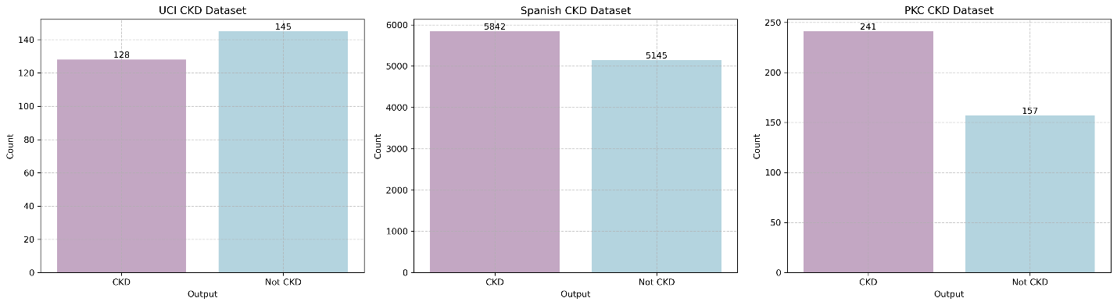
Figure 2. Distribution of CKD and Not CKD cases across the three datasets
This class distribution is critical for understanding potential biases and for selecting appropriate evaluation metrics during model training and testing.
C. Data Serialization for LLMs:
We are using LLM to perform predictions on clinical data, but it cannot process tabular data, just like traditional Machine Learning Models. To make LLM process tabular data ,the table must be transformed into natural language text . We used Text GPT3 method to serialize the tabular data into natural language text as mentioned in [11] . Figure 3 illustrates the transformation of each tabular patient record into an LLM-readable textual sequence via serialization, following an instruction-tuning format (instruction, input, output) used for model training/inference.
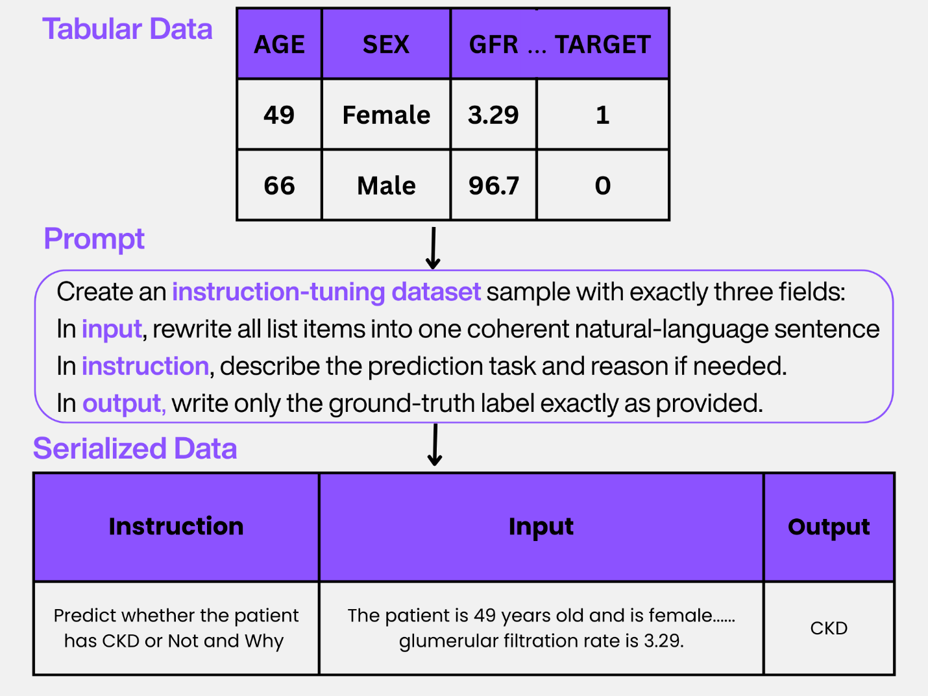
Figure 3 illustrates the process of transforming structured tabular clinical data into a serialized format suitable for instruction-tuned Large Language Models (LLMs).
This serialized format is used for model training and inference, enabling LLMs to generate predictions and rationales from clinical descriptions. The data format shown in Section (b) of Figure 1 was derived using the serialization method depicted in Figure 3.
D. Model Training and Evaluation :
This section describes the predictive modeling strategies along with explainability of prediction employed in this study. We used traditional ml model training approach and llm finetuning and to compare the results as depicted in Figure 1 section (a) and (b). Both models were trained and evaluated on identical datasets to ensure a fair and consistent benchmarking protocol.
3.1.1 ML Model as Baseline :
In this study, we selected Random Forest (RF) [25] as the primary machine learning baseline for comparison with the LLM-based approach. Random Forest was chosen due to its common usage in tabular classification tasks and its reputation for delivering strong average performance across diverse datasets [1]. By aggregating predictions from multiple decision trees, RF reduces variance and improves generalization, making it particularly effective for structured clinical data such as CKD patient records. Its widespread adoption in medical machine learning studies further supports its role as a reliable benchmark against which the performance of LLMs can be evaluated.
3.1.2 Large Language Model Fine-Tuning on Serialized Data:
A pre-trained Large Language Model (LLM) was employed to be finetuned for CKD prediction and explanation. Specifically , the Gemma-3N-E4B-it model which is a 1b parameter variant of Gemma-3N-E4B was selected due to its small size and efficient performance as we had limited compute to conduct this experiment.
Parameter-Efficient Fine-Tuning (PEFT)
To reduce computational cost and mitigate overfitting, Parameter-Efficient Fine-Tuning (PEFT) [22] was employed using Low-Rank Adaptation (LoRA) [23] . LoRA works by keeping base model parameters frozen, and introducing only a small set of trainable low-rank adapter matrices into the attention, and feed-forward layers of the model. Additionally, 4-bit quantization was applied to the base model weights (QLoRA) [24], significantly reducing memory and computational requirements with negligible impact on model performance. The model was fine-tuned using supervised instruction tuning with gradient accumulation to enable a larger batch size.
During supervised fine-tuning, we configured the training loop with a maximum of 60 steps for the PKC and UCI tasks, and 100 steps for the SPN task (max_steps). We used a learning rate of 2 × 10⁻⁴, which strikes a balance between stable convergence and effective adaptation. To support larger effective batch sizes without exceeding memory limits, we applied gradient accumulation with 4 steps (gradient_accumulation_steps = 4).
For optimization, we selected 8-bit AdamW (optim = "adamw_8bit") with a weight decay of 0.01 to regularize the model and help mitigate overfitting. Within LoRA, we set the rank (r) to 8 and LoRA alpha to 8, which controls the expressiveness and scaling of the low-rank adapter matrices inserted into the attention and feed-forward layers.
These hyperparameters, in conjunction with QLoRA quantization and frozen base weights, enabled efficient fine-tuning that preserved performance while greatly reducing compute and memory demands.
Evaluation Metrics :
The predictive performance is quantified using the following mathematical formulations, where $TP$, $TN$, $FP$, and $FN$ represent True Positives, True Negatives, False Positives, and False Negatives, respectively:
Table IV Evaluation Metrics Table
Metric | Formula | Description
Accuracy | $$\frac{TP+TN}{TP+TN+FP+FN}$$ | The overall proportion of correct CKD predictions
Precision | $$\frac{TP}{TP+FP}$$ | The ability of the model to avoid false positives in diagnosis.
Recall | $$\frac{TP}{TP+FN}$$ | The sensitivity of the model in identifying all actual CKD cases
F1-Score | $$2×\frac{Precision×Recall}{Precision+Recall}$$ | The harmonic mean of precision and recall for balanced evaluation
ROC-AUC | $$\int_{0}^{1}{TPR(FP}R^{-1}(u))du$$ | Measures the model's ability to distinguish between CKD and non-CKD classes across all thresholds

Algorithm 1: Fine-Tuning Large Language Models for CKD Prediction and Natural Language Explanation
Input:
Heterogeneous CKD datasets
$$D=\{D_{PKC},D_{UCI},D_{SPN}\}$$Pre-trained instruction-tuned LLM $M_{θ}$
PEFT hyperparameters: rank $r$, LoRA scaling $α$, learning rate $η$
Output:
Fine-tuned LLM $M_{θ^{'}}$
Patient-specific natural language rationales $R$
Evaluation vector $V_{\text{eval}}$

Step 1: Data Preprocessing
For each dataset $D_{i}∈D$:
- Handle missing values using column-wise imputation.
- Detect and remove outliers using the Interquartile Range (IQR) method:
$$IQR=Q_{3}-Q_{1},x∉[Q_{1}-1.5⋅IQR, Q_{3}+1.5⋅IQR]$$
- Encode categorical features and normalize numerical attributes.
- Split the dataset into training and testing subsets using an 80/20 ratio.

Step 2: Baseline Machine Learning Training (Random Forest)
- Initialize a Random Forest classifier $RF_{ϕ}$.
- Train the model on structured clinical features from $D_{\text{train}}$.
- Generate CKD predictions ${\hat{y}}_{RF}$on $D_{\text{test}}$.
- Store performance metrics for benchmarking.

Step 3: Natural Language Serialization
- Define a serialization template $T$following an instruction-tuning format.
- Convert each structured clinical record $x_{i}$into natural language:
$$S_{i}=T(x_{i})⇒\{\text{Instruction}, \text{Clinical Description}, \text{Label}\}$$
- Construct serialized training set $S_{\text{train}}$and test set $S_{\text{test}}$.

Step 4: Parameter-Efficient Fine-Tuning via QLoRA
- Quantize base model weights using 4-bit NormalFloat (NF4):
$$W_{\text{quant}}=\text{quant}(W_{0})$$
- Insert low-rank adapter matrices $A∈R^{d×r}$, $B∈R^{r×d}$.
- Perform supervised instruction tuning using the LoRA forward pass:
$$h=W_{\text{quant}}x+\frac{α}{r}(BA)x$$
- Update only adapter parameters using 8-bit AdamW optimizer.

Step 5: Evaluation and Rationale Generation
- Evaluate both $RF_{ϕ}$and $M_{θ^{'}}$on the test set.
- Compute confusion matrix components $\left\{TP , TN , FP , FN\right\}$.
- Derive evaluation metrics:
$$V_{\text{eval}}=\{\text{Accuracy}, \text{Precision}, \text{Recall}, \text{F1-score}, \text{ROC-AUC}\}$$
- Generate patient-specific clinical rationales using self-explanation prompting:
$$R=M_{θ^{'}}(S_{\text{test}}∣\text{“Explain the clinical reasoning behind this prediction”})$$
Results :
This section presents the experimental results obtained after benchmarking the models against three different datasets. We evaluate both predictive performance and the quality of generated explainability be each model , highlighting the strengths and limitations of each approach.
Predictive Performance :
The predictive performance of the fine-tuned Large Language Model (LLM) and the Random Forest (RF) baseline was evaluated on the test sets of the PKC, UCI, and Spanish (SPN) CKD datasets using the metrics presented in Table III, as illustrated in Figure 4.
Across the PKC and UCI datasets, the LLM achieved performance comparable to the traditional ML baseline as seen in Fig 4 (a,b). However, a performance decline was observed on the larger SPN dataset Fig 4 (c) , consistent with prior studies [11,21] showing that LLMs perform well in few-shot settings but do not outperform traditional ML models on large-scale tabular data. In contrast RF maintained stable performance across all three datasets.
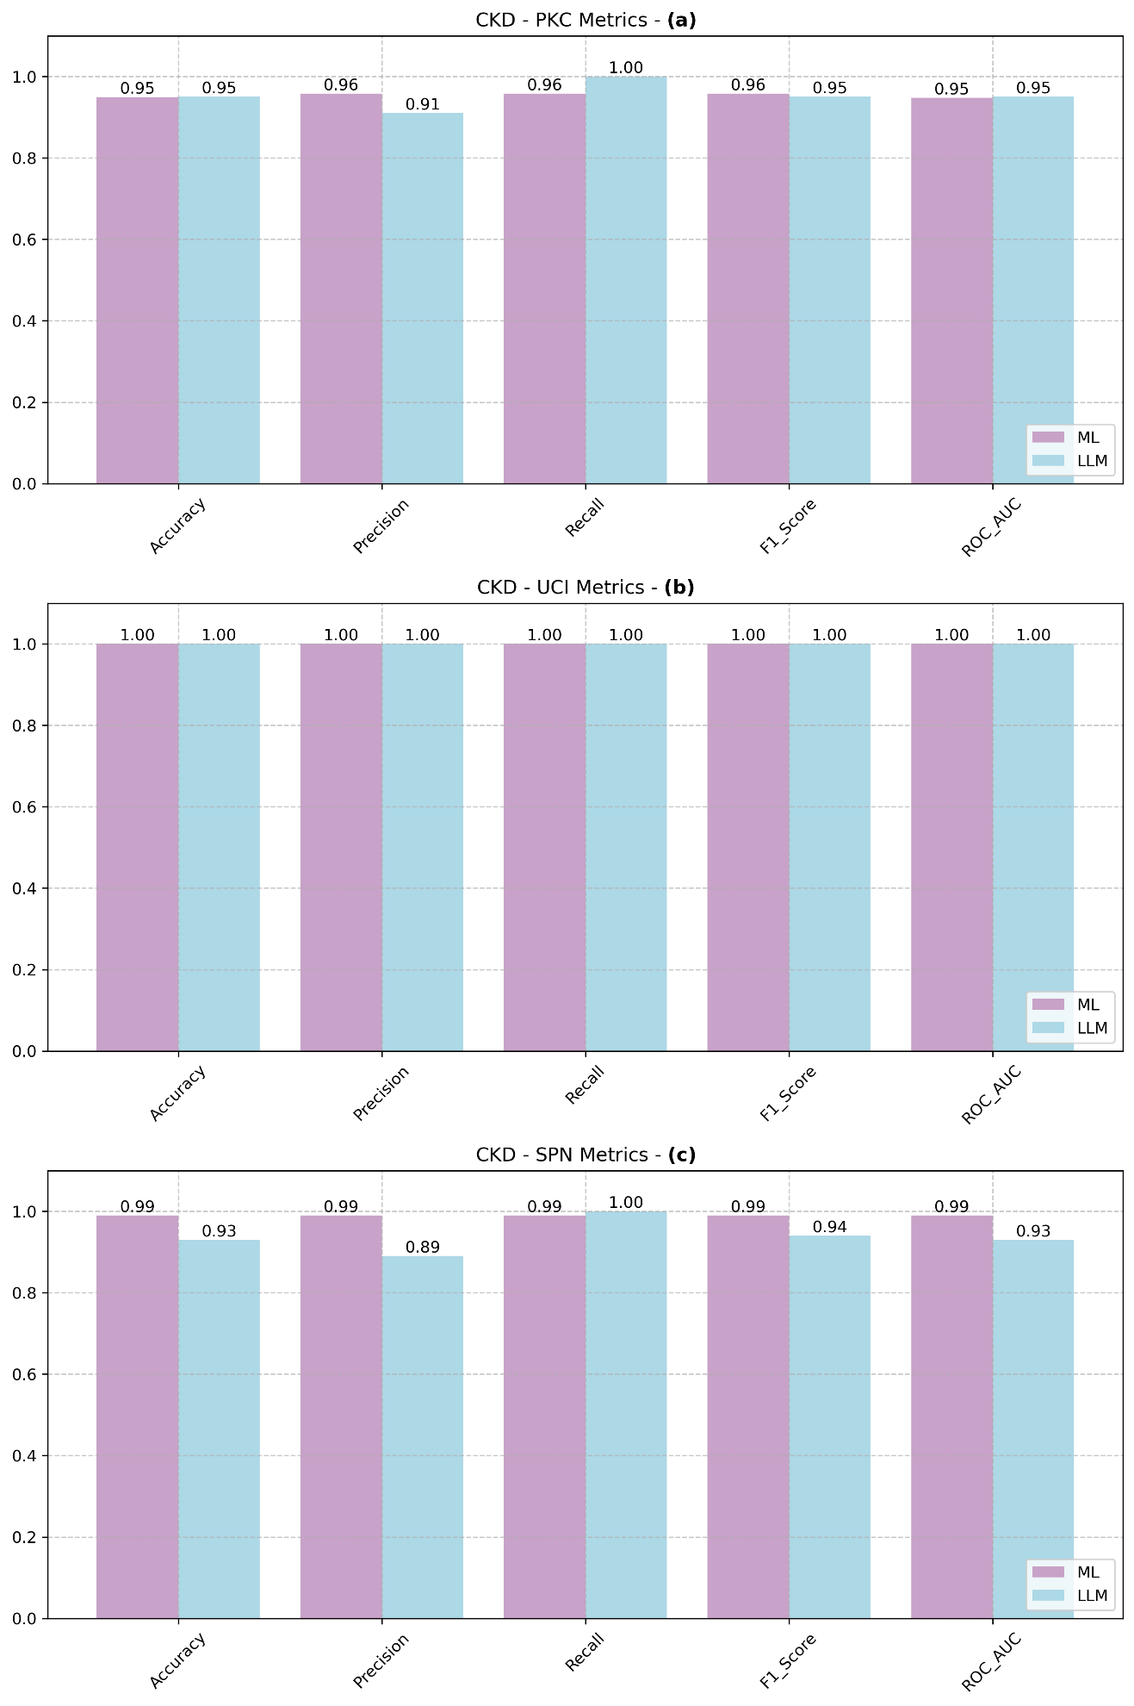
Figure 4. Predictive performance comparison between the Random Forest (ML) baseline and the fine-tuned Large Language Model (LLM) across the PKC, UCI, and Spanish (SPN) CKD datasets.
This behavior is further confirmed by the confusion matrices shown in Figure 5. On the PKC dataset, the LLM produced more number of false negatives and zero false positives, as illustrated in Figure 5(b), while successfully identifying all CKD-positive cases. This limitation becomes more evident on the large-scale SPN dataset, where the LLM incorrectly labeled 147 non-CKD instances as CKD, whereas the Random Forest model demonstrated more robust pattern extraction with only one false positive and one false negative, as shown in Figure 5(e–f). This behavior indicates that the fine-tuned LLM prioritizes recall over precision in the evaluated setting, as shown in Figure 4(a–c), where the model consistently achieves 100% recall across all three datasets.

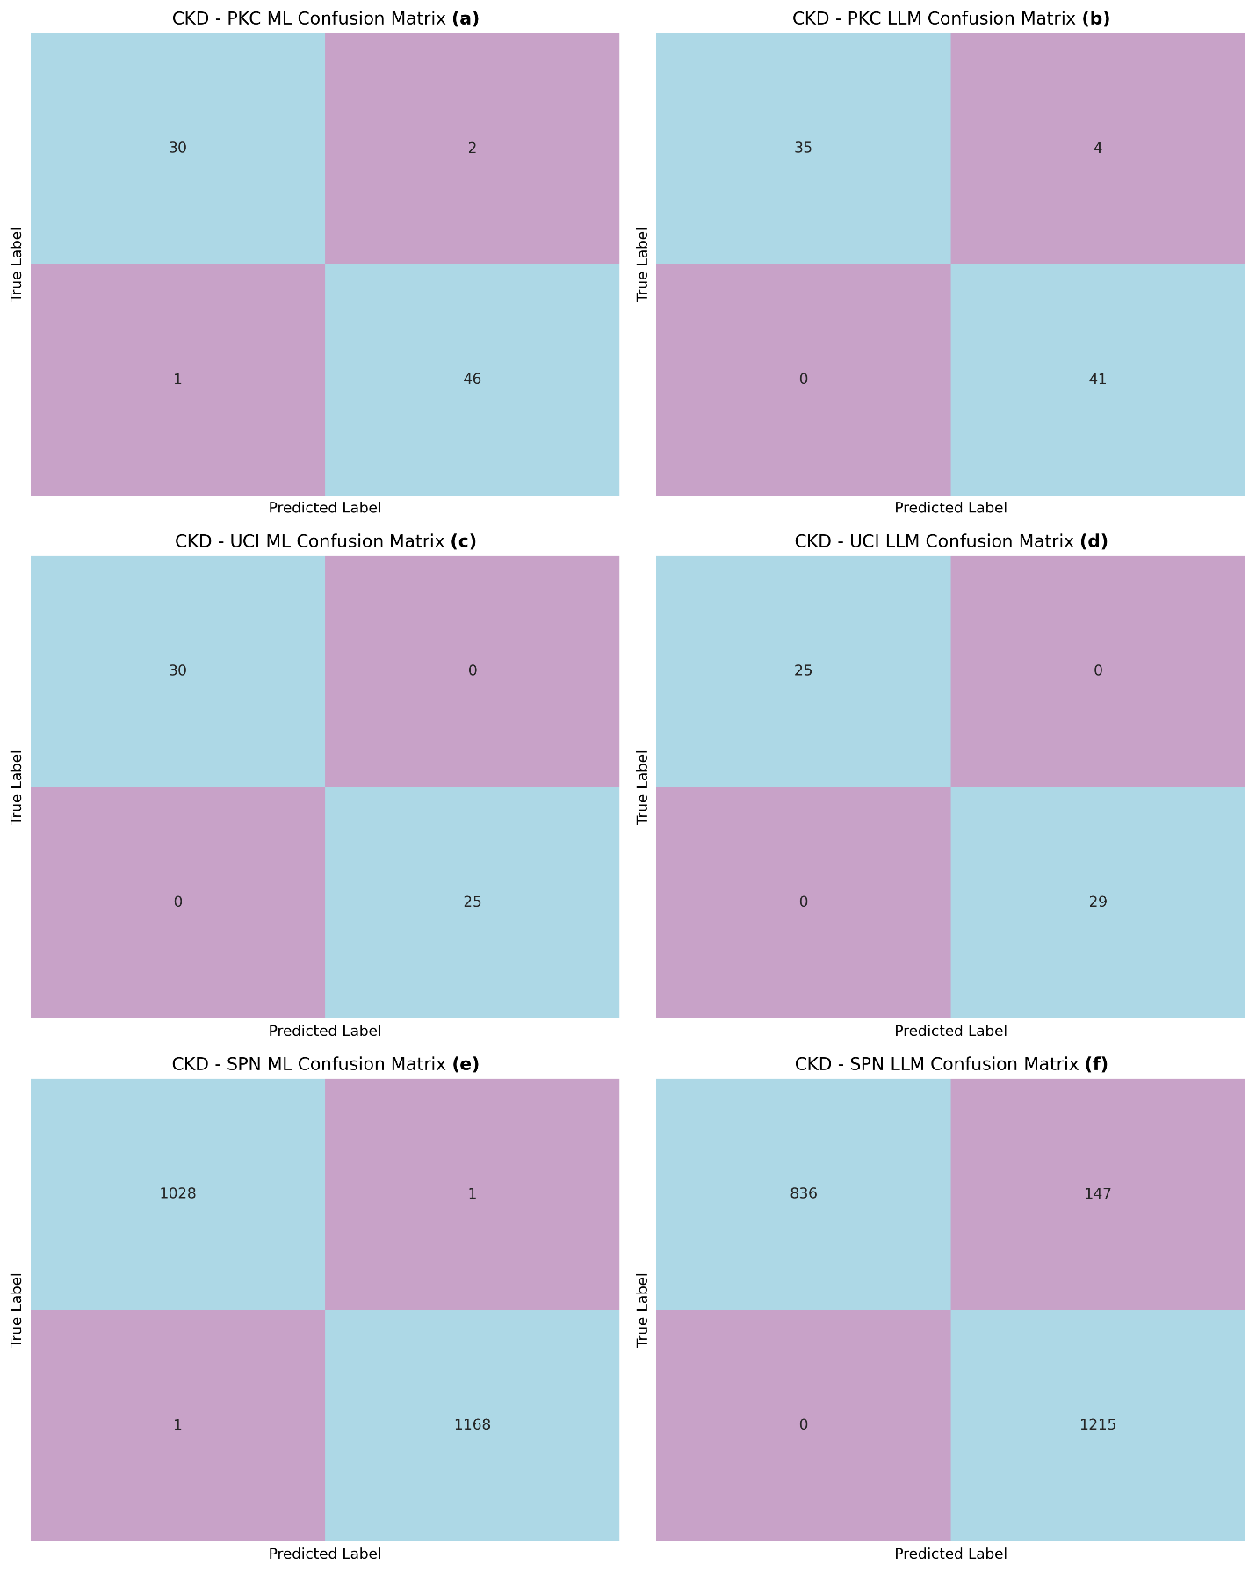
Figure 5. Confusion matrices for CKD prediction using the Random Forest (ML) and Large Language Model (LLM) across the PKC, UCI, and Spanish (SPN) datasets, illustrating differences in error distribution.
These findings are consistent with earlier studies [11,21], which show that LLMs perform well on small to medium tabular datasets but struggle compared to traditional machine learning models on larger structured data. In our experiments, the fine-tuned LLM consistently favored recall over precision, achieving 100% recall across all datasets. However, this emphasis on recall increases false negatives, where CKD cases are incorrectly classified as healthy. This is problematic, as it may prevent patients from receiving early CKD interventions. In clinical practice, such misclassification can lead to missed diagnoses, additional follow-up tests, greater workload for clinicians, and reduced trust in automated tools ,making LLMs less practical than more balanced traditional models.
Explainability Comparison :
We will use a framework to compare the explainability of both models using a framework focused on accessibility and usability as mentioned in Table iv . This framework evaluates how effectively each model communicates its predictions to end users. Figure 6 provides a side-by-side comparison of how each model justifies its predictions for two distinct scenarios: a positive Chronic Kidney Disease (CKD) case and a negative case.
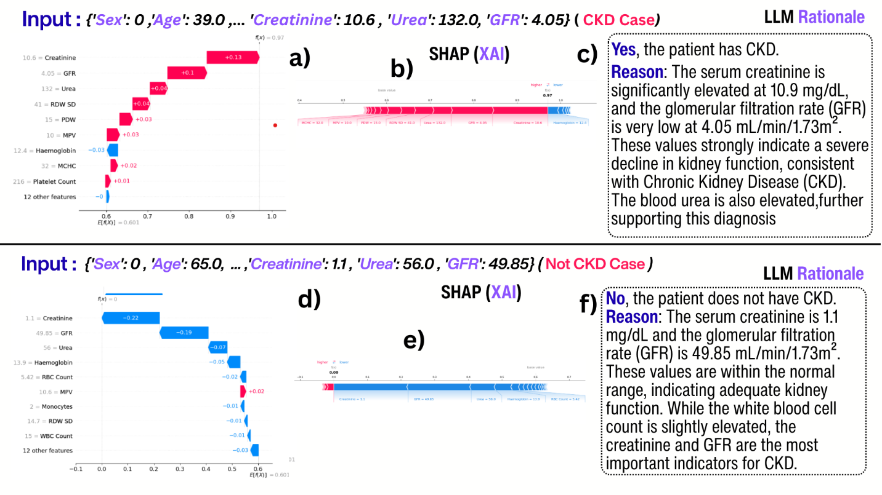
Figure 6. Comparison of Technical XAI (SHAP) vs. LLM Natural Language Rationales.
For traditional ML, Figure 6(a) and 6(d) represent SHAP waterfall plots, which break down the final prediction into individual feature contributions, while Figure 6(b) and 6(e) display SHAP force plots, showing the mathematical "push" of features toward a specific outcome. In contrast, Figure 6(c) and 6(f) present the LLM natural language rationales, which provide a structured narrative explaining the diagnosis in plain text.

Table V. Explainability Comparison Framework
Feature | SHAP/LIME (Traditional ML) | Natural Language Rationale (LLM) | Preferred Method
Output Format | Technical Graphs & Numerical Weights | Structured Narrative Sentences | LLM ✅
Target Audience | ML Experts / Data Scientists | Clinicians / Non-Technical Users | LLM ✅
Understanding Effort | High (Requires technical literacy) | Low (Immediate, intuitive reading) | LLM ✅

By applying this framework to the results in Figure 6, we identify the LLM as the superior method for clinical integration. While SHAP relies on abstract visuals and mathematical correlations, the LLM provides contextual reasoning that translates raw values into a clinical conclusion. The SHAP plots are primarily optimized for developers and data scientists , whereas the LLM rationales are tailored for clinicians and for real-world diagnostic decision support. Consequently, the understanding effort for the LLM is minimal; a practitioner can verify the "Reason" block in seconds, whereas interpreting force plots involves a higher cognitive load to map statistics to health outcomes. Therefore, based on the criteria in Table IV and the visual evidence in Figure 6, the fine-tuned LLM emerges as the superior explainability solution.
Discussion :
This study evaluated the feasibility of using fine-tuned LLMs for Chronic Kidney Disease (CKD) classification and explanation, benchmarking them against a Random Forest (RF) baseline across multiple datasets. The results reveal a clear trade-off between predictive performance and explainability, emphasizing that the suitability of each approach depends on the intended clinical role.
In terms of predictive accuracy, traditional machine learning models remain more reliable for structured clinical data. The RF baseline demonstrated stable performance across all datasets, including the large Spanish cohort, while the LLM achieved comparable results only on small to medium-sized datasets. Performance degradation on larger data confirms prior findings that LLMs perform well in few-shot or low-data regimes but do not consistently outperform classical models on large-scale tabular prediction tasks. Moreover, LLMs are inherently unsuitable for regression-based objectives, such as continuous risk scoring or CKD progression modeling, where numerical precision and temporal consistency are essential.
Despite these limitations, LLMs offer a substantial advantage in explainability. SHAP-based explanations provide mathematically grounded feature attributions but require technical expertise to interpret, making them less practical for routine clinical use. In contrast, the LLM-generated natural language rationales translate raw clinical values into coherent, diagnosis-oriented narratives that closely resemble clinical reasoning. This significantly reduces cognitive load and enables rapid validation of predictions by non-technical users.
These findings highlight an unavoidable trade-off: adopting LLMs as prediction models requires accepting a modest reduction in predictive performance in exchange for superior usability and interpretability. In clinical decision support systems, where transparency, trust, and speed of understanding are critical, this trade-off may be justified. Consequently, LLMs should not be viewed as replacements for traditional machine learning models, but rather as complementary tools that excel in delivering user-centered explanations.
Overall, this work underscores the importance of evaluating explainability from a human-centered perspective. While traditional models remain preferable for high-precision prediction and regression tasks, LLMs outperform existing explainability frameworks in delivering intuitive, clinician-friendly reasoning, making them valuable components in future interpretable clinical AI systems.
Conclusion :
This research proposes an end-to-end CKD prediction framework that fine-tunes a medical LLM on serialized clinical tabular data using LoRA/QLoRA via Unsloth, enabling efficient training and competitive classification performance across multiple datasets. Beyond prediction, the model generates patient-specific natural language rationales, providing a more accessible and clinician-oriented form of interpretability than traditional post-hoc explanation techniques. While traditional machine learning models remain superior for large-scale tabular prediction and regression-based tasks, the results demonstrate that LLMs offer a compelling trade-off by significantly improving usability and transparency of model reasoning. Overall, this work supports the feasibility of integrating prediction and explanation within a single fine-tuned LLM and motivates future research on prospective clinical validation, robustness of serialization templates, and faithfulness-aware rationalization strategies.
References :
- Zhu, Y., et al. (2023). "Predict, diagnose, and treat chronic kidney disease with machine learning: a systematic literature review." Journal of Nephrology, 36(4), 1017-1031.​
- Kaur, P., & Sharma, M. (2023). "Explainable Machine Learning Model for Chronic Kidney Disease Prediction." International Journal of Cognitive Computing in Engineering, 4, 1-12.​
- S. K. Ghosh and A. H. Khandoker, “Investigation on explainable machine learning models to predict chronic kidney diseases,” arXiv preprint arXiv:2406.06728, 2024. Available: https://arxiv.org/abs/2406.06728
- Alasadi, A. S., et al. (2024). "Development and evaluation of an Explainable Prediction Model for Chronic Kidney Disease Patients based on Ensemble Trees." Health Information Science and Systems, 12(1), 15.​
- Vashisth, S., et al. (2023). "Prediction of Chronic Kidney Disease - A Machine Learning Perspective." Journal of Physics: Conference Series, 2468(1), 012005.​
- Kim, J. S., et al. (2023). "Prediction of chronic kidney disease progression using recurrent neural network and electronic health records." Scientific Reports, 13(1), 1145.​
- Reddy, A. S., et al. (2024). "A Study on the Application of Explainable AI on Ensemble Models for Predictive Analysis of Chronic Kidney Disease." Procedia Computer Science, 235, 120-130.​
- Sharma, R., & Gupta, S. (2024). "Chronic Kidney Disease Detection Augmented with Hybrid Explainable AI." Expert Systems with Applications, 238, 121845.​
- Wiegreffe, S., & Marasovic, A. (2021). "Rationalization for explainable NLP: a survey." arXiv preprint arXiv:2101.07561.​
- Lee, H., et al. (2025). "Can large language models provide accurate and quality information to parents regarding chronic kidney diseases?" Journal of Renal Care, 51(1), 45-56.​
- Hegselmann, S., et al. (2023). "TabLLM: Few-shot Classification of Tabular Data with Large Language Models." Proceedings of the 26th International Conference on Artificial Intelligence and Statistics (AISTATS).​
- Wang, Z., et al. (2024). "SuLaLoM: Structured Classification of Tabular Data with Large Language Models." arXiv preprint arXiv:2402.12345.​
- Hollmann, N., et al. (2023). "TabPFN: A Transformer That Solves Small Tabular Classification Problems in a Second." International Conference on Learning Representations (ICLR).
- W. Khalil, K. Bashir, and M. Mosadag, "Early detection of Chronic Kidney Disease (CKD) using machine learning algorithms," 2025.
- N. Vijay Kumar, “Chronic Kidney Disease Prediction Using Machine Learning and Deep Learning Models,” in Proceedings of the 2025 IEEE International Conference on Interdisciplinary Approaches in Technology and Management for Social Innovation (IATMSI), 2025, pp. –, doi: 10.1109/IATMSI64286.2025.10985476.
- Arpit Pathak, Om Prakash Singh, and Ujjwal Biswas. "Predicting Chronic Kidney Disease Using Machine Learning Methodologies." 2025 8th International Conference on Electronics, Materials Engineering & Nano-Technology (IEMENTech). IEEE, Kolkata, India, 31 Jan–2 Feb 2025. DOI: 10.1109/IEMENTech65115.2025.10959624
- A. K. Mondol, D. Das, T. Yasmin, S. S. Arjon, S. M. H. S. Iqbal, and N. Aman, “Support Vector Machine Model for Enhancing the Accuracy of Chronic Kidney Disease Risk Prediction,” 2025 6th International Conference on Electrical, Computer and Communication Engineering (ECCE), Rajshahi, Bangladesh, Jan. 10–12, 2025. IEEE. DOI: 10.1109/ECCE59371.2025.11172008
- Sharma, S., Saruchi, Narwal, A., Meghana, K. C., Singh, M., Maurya, R. K., & Upadhyay, Y. (2025). Machine learning algorithm for detecting and predicting chronic kidney disease. Biomedical & Pharmacology Journal, 18(2), 1230–1245. https://doi.org/10.13005/bpj/3165
- Jawad, K. M. T., Verma, A., Amsaad, F., & Ashraf, L. (2025). A study on the application of explainable AI on ensemble models for predictive analysis of chronic kidney disease. IEEE Access. Advance online publication. https://doi.org/10.1109/ACCESS.2024.0429000 (doi.org in Bing)
- Hollmann, N., Müller, S., & Hüllermeier, E. (2022). TabPFN: A Transformer That Solves Small Tabular Classification Problems in a Second. arXiv preprint arXiv:2207.01848. https://arxiv.org/abs/2207.01848
- Chen, C., Yu, J., Chen, S., Liu, C., Wan, Z., Bitterman, D. S., Wang, F., & Shu, K. (2024). ClinicalBench: Can LLMs Beat Traditional ML Models in Clinical Prediction? arXiv preprint arXiv:2411.06469. https://arxiv.org/abs/2411.06469
- Xu, L., Xie, H., Qin, S.-Z. J., Tao, X., & Wang, F. L. (2023). Parameter-Efficient Fine-Tuning Methods for Pretrained Language Models: A Critical Review and Assessment. arXiv preprint arXiv:2312.12148.
- Hu, E. J., Shen, Y., Wallis, P., Allen-Zhu, Z., Li, Y., Wang, S., Wang, L., & Chen, W. (2021). LoRA: Low-Rank Adaptation of Large Language Models. arXiv preprint arXiv:2106.09685. (Also published at ICLR 2022).
- Dettmers, T., Pagnoni, A., Holtzman, A., & Zettlemoyer, L. (2023). QLoRA: Efficient Finetuning of Quantized LLMs. arXiv preprint arXiv:2305.14314. (Also published at NeurIPS 2023).
- Breiman, L. (2001). Random forests. Machine Learning, 45(1), 5–32.

